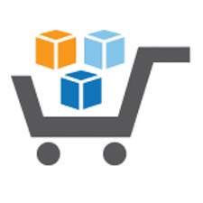

**Running an Intelligent Analytical System on AWS**

**Using AWS Services & Solutions in AWS Marketplace**

Step-by-Step Deployment Guide – Part 1

Disclaimer:

1. The AWS Marketplace Fusion Solution showcased in this document is solely meant as a tutorial, *but with given additional customizations, it can be used for production use cases*.
2. Technologies used in this Solution can be replaced by other equivalent technologies as needed for business reasons.
3. All data used in this Solution is machine generated and fictitious.
4. For setting up this AWS Marketplace Fusion Solution, prior knowledge of the technologies used in the Solution and familiarity with Amazon AWS Cloud is recommended.
5. For most of the components, we used the region **US West (Oregon)**, but you can change it as per your choice.

**Table of Contents**

[1. Introduction 4](#_Toc468290049)

[2. Business Use Case 8](#_Toc468290050)

[3. Audience 9](#_Toc468290051)

[4. Step by Step Deployment Guide 10](#_Toc468290052)

[4.1. Setup VPC (Virtual Private Cloud) 12](#_Toc468290053)

[4.2. Storage setup using SoftNAS (B) 15](#_Toc468290054)

[4.3. Setup the Warehouse using Amazon Redshift Data Warehouse (E) 29](#_Toc468290055)

[4.3.1. Cluster Details 30](#_Toc468290056)

[4.3.2. Node Configuration 30](#_Toc468290057)

[4.3.3. Additional Configuration 32](#_Toc468290058)

[4.3.4. Review 33](#_Toc468290059)

[4.4. Setup the ETL Tool using ATTUNITY CloudBeam ETL (C) 36](#_Toc468290060)

[4.4.1. Launch ATTUNITY CloudBeam Instance 36](#_Toc468290061)

[4.4.2. Connect to ATTUNITY CloudBeam instance remotely 41](#_Toc468290062)

[4.4.3. Set ATTUNITY CloudBeam Password 43](#_Toc468290063)

[4.4.4. Install ATTUNITY Replicate software 45](#_Toc468290064)

[4.4.5. Install MySql 5.5 47](#_Toc468290065)

[4.4.6. Install MySQL Connector/ODBC driver 48](#_Toc468290066)

[4.4.7. Create MySQL Database 51](#_Toc468290067)

[4.4.8. Create Bucket 54](#_Toc468290068)

[4.4.9. Create ATTUNITY Replicate Endpoint Connections 55](#_Toc468290069)

[4.4.10. Create ATTUNITY Replicate Task 60](#_Toc468290070)

[4.5. Visualization setup using TIBCO Spotfire Analytics platform (G) 64](#_Toc468290071)

[4.5.1. Launch TIBCO Spotfire instance 64](#_Toc468290072)

[4.5.2. Install Python 70](#_Toc468290073)

* + - 1. Introduction

This document is the continuation of the Overview Document.

This project is the first of 3 projects, which should be executed sequentially:

1. **Project 1**: Step by Step Deployment Guide – Part 1

Step by Step Deployment Guide – Part 2

2. **Project 2:** Data Pipeline

3. **Project 3:** Machine Learning, Reporting, and BYOD

Refer to the following architecture diagram below for the overall data flow and the system/solution information.

C:\Users\Abhinandan\Desktop\Diagram\aws_marketplace_immersion_project_HLA.png

The following is the list of the recommended server/instance types that you will need for each of the components:

|  |  |  |  |  |  |  |  |
| --- | --- | --- | --- | --- | --- | --- | --- |
| **Component #** | **Component Name** | **EC2 Server Type** | **Operating System Type** | **Set Up Complexity** | **License Required?** | **Source of Component** | **Purpose** |
| A | **Amazon S3** | NA | NA | NA | No | AWS Marketplace | Storage |
| B | **SoftNAS** | m3.xlarge | Unix/Linux | Medium | Yes | AWS Marketplace | Storage Management Software |
| C | **ATTUNITY CloudBeam** | m4.large | Screenshots Server 2008 | High | Yes | AWS Marketplace | ETL Software |
| D | **MySQL** | m4.large | Screenshots Server 2008 | High | Yes | Microsoft Web Platform Installer | Database |
| E | **Amazon RedShift** | NA | NA | High | Yes | AWS Marketplace | Storage |
| F | **R** | m4.large | Screenshots Server 2012 | Low | No | Open Source | Predictive Analytics |
| G | **TIBCO Spotfire** | m4.large | Screenshots Server 2012 | Medium | Yes | AWS Marketplace | Visualization software |
| H | **Kony Mobile Fabric** | t2.large | Amazon Linux | High | Yes | AWS Marketplace | Mobile App development |
| I | **TREND Micro Security** | m4.large | Amazon Linux | High | Yes | AWS Marketplace | Security Software |
| J | **Amazon VPC** | NA | NA | NA | No | AWS Marketplace | Virtual Cloud |
| K.1 | **Tomcat Server 1** | m4.large | Screenshots Server 2012 | Low | No | Open Source | Host dashboard automation process |
| K.2 | **Tomcat Server 2** | m4.large | Screenshots Server 2012 | Low | No | Open Source | Host cloudbeam automation process |

[Click here](https://aws.amazon.com/ec2/instance-types/) to find out more about different instance types available in AWS Marketplace.

* + - 1. Business Use Case

Please refer to the Overview document for the Business Use Case used in this solution.

3. Audience

This document is designed for different types of audiences. Therefore, each of the steps are explained in detail. Below is a list of job titles who can explore this document:

**Enterprise Organization**

* Developer
* IT Professional
* IT Manager

**Medium to Small Organization**

* DevOps

4. Step by Step Deployment Guide

Before executing any step below, you **must** execute all steps from the Prerequisites document that can be found at the Git repository below:

The name of the Prerequisites document is:

*Prerequisites.pdf*

This document will demonstrate how to deploy and configure the following technologies/components that are used to build an AWS Cloud Based Analytic System:

1. VPC
2. MySQL Server
3. Amazon S3
4. Amazon Redshift
5. ATTUNITY CloudBeam
6. TIBCO Spotfire
7. SoftNAS
8. R
9. Kony Mobile Fabric
10. TREND Micro Security
11. Apache Tomcat Servers
12. Apache Maven

This document will walk you through the following steps:

**4.1:** Setup **VPC** (Virtual Private Cloud).

**4.2:** Storage setup using **SoftNAS** (B).

**4.3:** Setup the Warehouse using **Amazon Redshift Data Warehouse** (E).

**4.4:** Setup the ETL Tool using **ATTUNITY CloudBeam** ETL (C).

**4.5:** Visualization using **TIBCO Spotfire** Analytics platform (G).

**4.6:** Setup the **R** environment for Predictive Analysis (F).

**4.7:** Setup Mobile alerts and notifications using **Kony Mobile Fabric** (H).

**4.8:** Securing the infrastructure and devices using **TREND Micro Security** (I).

**4.9:** Setup the Solution code tree and datasets in **Github** repository cloning.

**4.10**: Enable Tomcat Servers for the Web Interface **Apache Tomcat Server** (K1, K2).

**4.11**: Build your code to deploy on a Server using **Apache Maven.**

4.1. Setup VPC (Virtual Private Cloud)

Custom VPC configuration steps are listed below. You will be using default VPC to keep it simple.

1. Login to AWS Account.
2. Click on VPC listed under Networking.

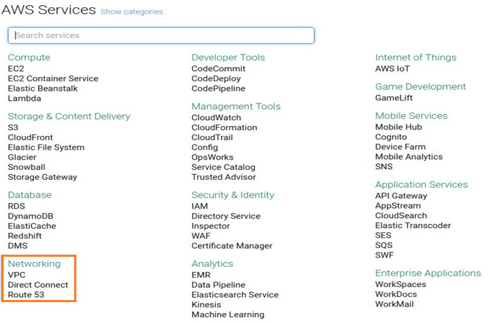

1. Click on Start VPC Wizard.

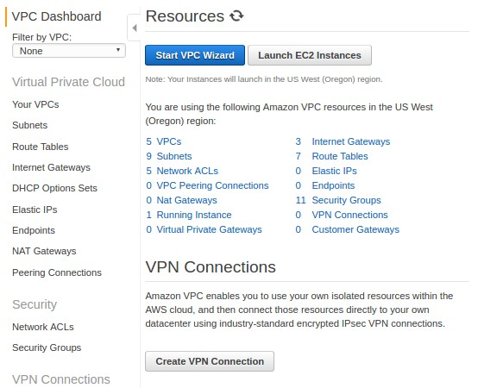

1. Then select the VPC Configuration – **VPC with a Single Public Subnet**. Click Select button as below.

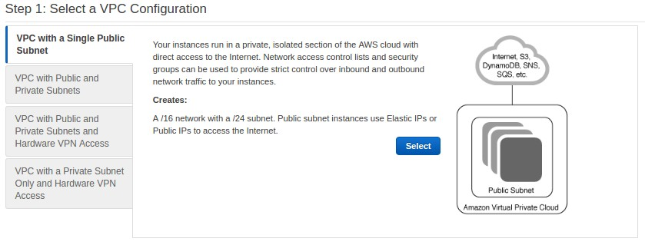

1. 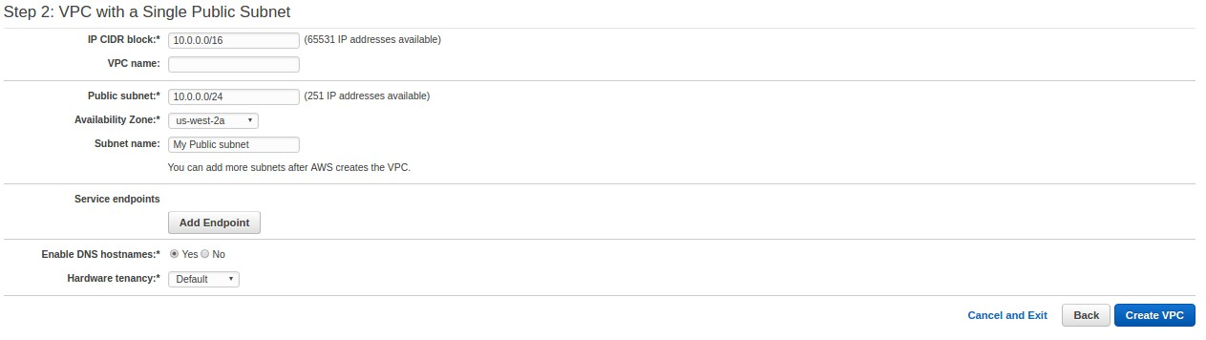Provide the **IP CIDR Block, VPC Name, Public subnet, Availability Zone** as required. Select **Yes** to **Enable DNS hostnames**. Then click on the **Create VPC** button.
2. Once all information are correct VPC will be created.



4.2. Storage setup using SoftNAS (B)

1. Login to your **AWS Management Console**. Please refer to the Prerequisites document for instructions on how to login.

2. In the right navigation panel, click on the link **Find and buy software** to open AWS Marketplace.

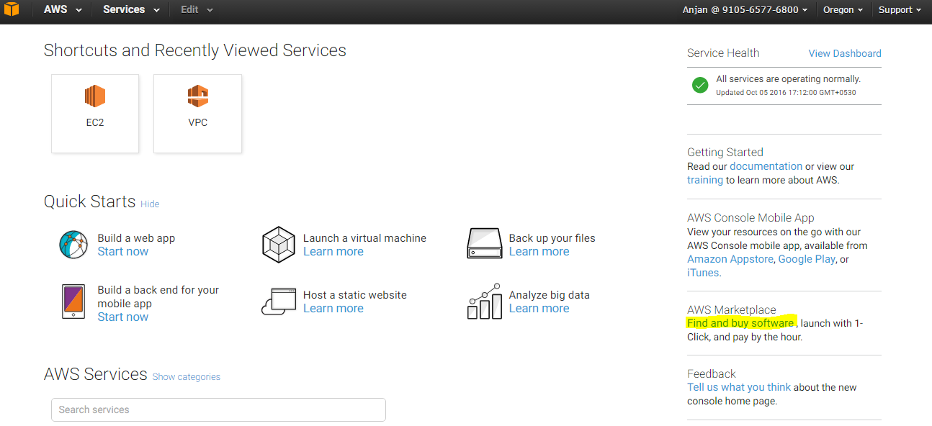

3. Type **SoftNAS** in the search box and click on the **Go** button.

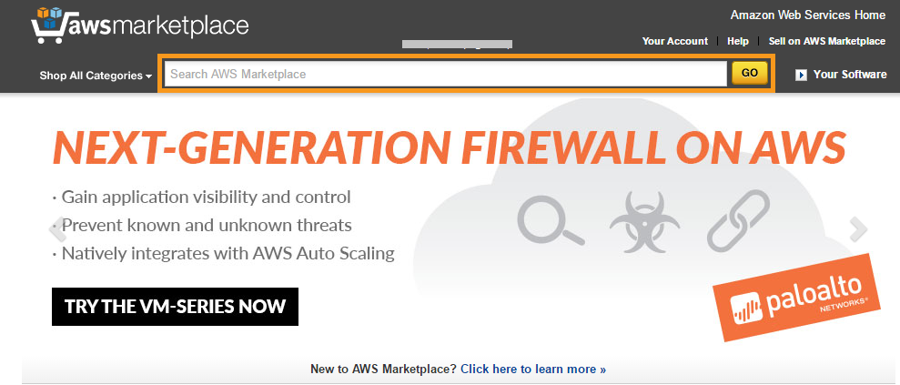

4. Select **SoftNAS Cloud Standard — High-Performance Cloud NAS (HVM/SRV-IO/20TB)** from the search result.

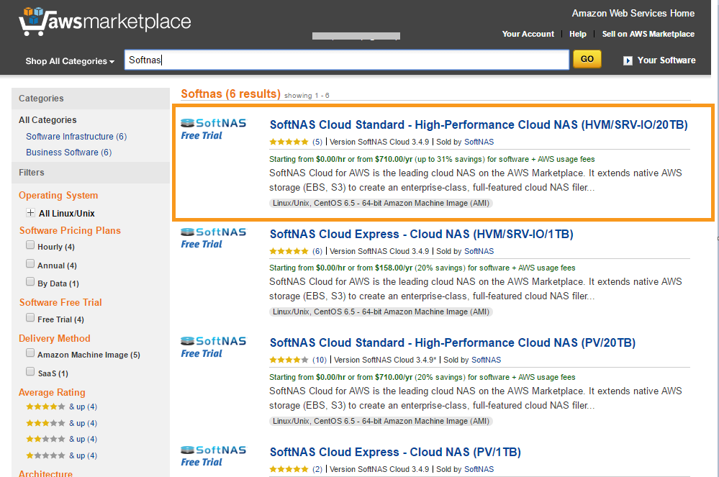

5. Click on the **Continue** button on the product description page of **SoftNAS**.

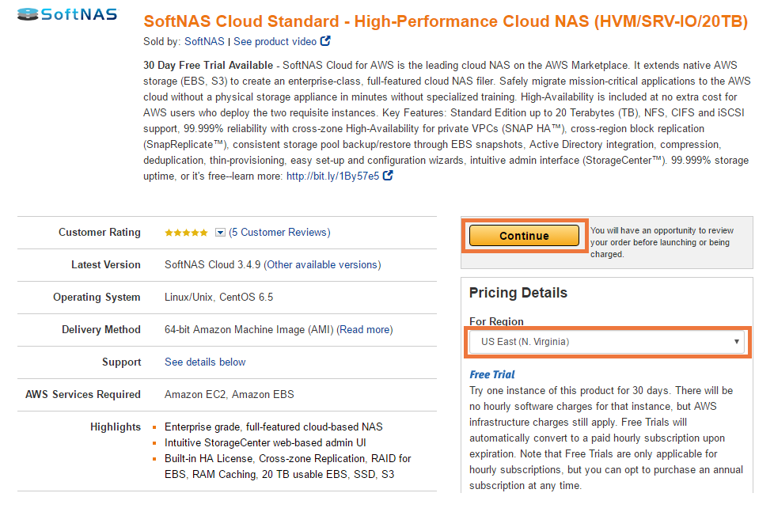

6. On the **Launch on EC2** page, make sure the **1-Click Launch** tab is selected.

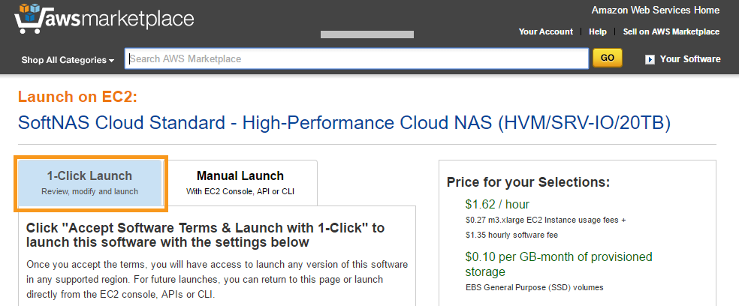

7. Set **Subscription** **Term** as **Hourly**.

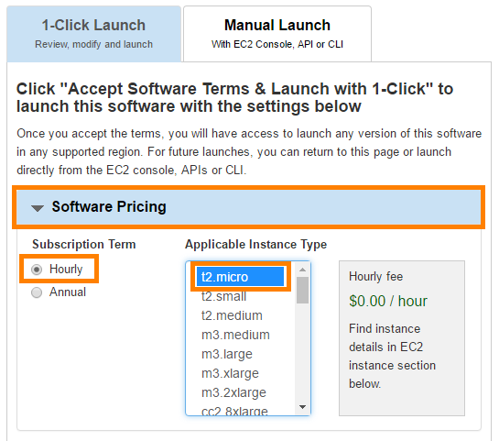

8. In the **Version** section, choose the latest version.

9. Select **US-West (Oregon)** as the default region for this project.

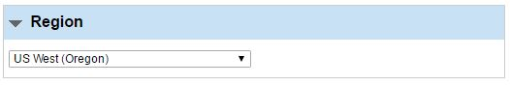

10. Select **m3.xlarge** for the EC2 Instance type.

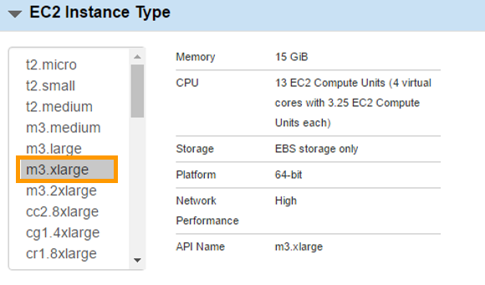

11. Select the default **VPC** and the default **Subnet**.

Default VPC and Subnet are preceded by an **asterisk** **“\*”**.

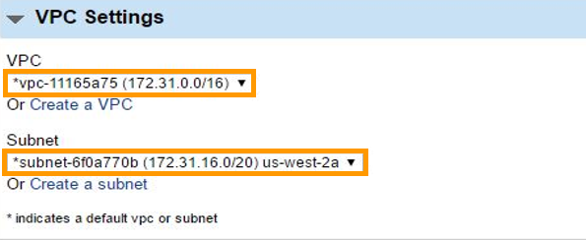

12. Select **default** Security Group.

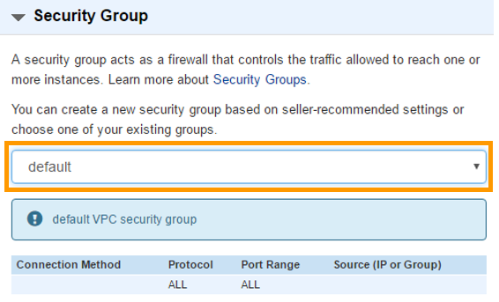

13. Follow the steps mentioned in **Section 1.4, “Generate Your Private Keys,” of the Prerequisites** document to generate your key pair, if you have not done this already.

14. Select the generated key pair for the **Key Pair** selection box.

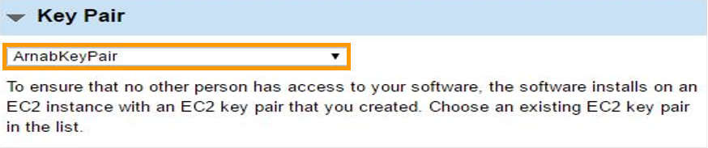

15. Scroll up and click on the **Launch with 1-Click button** to start the SoftNAS installation process.

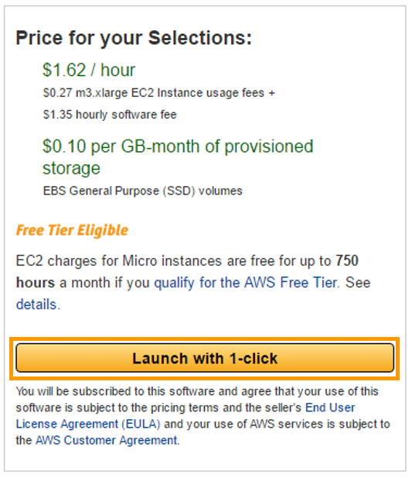

Wait a few minutes until the installation completes.

16. **Go to the EC2 dashboard to get the newly created SoftNAS instance.**

17. Provide proper name to your newly-created SoftNAS instance and select it.

At the bottom of the instances list, you will find a panel containing details of the selected instance.

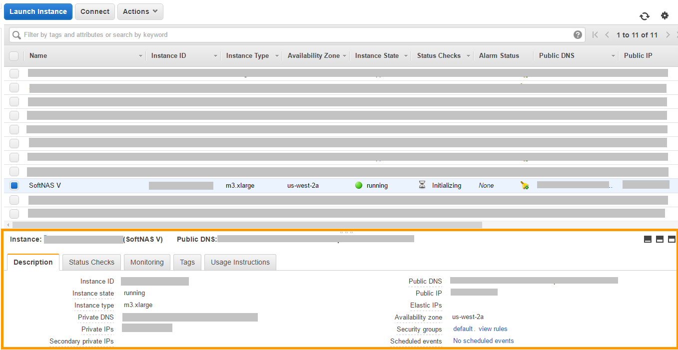

18. Select the **Description** tab in the details panel.

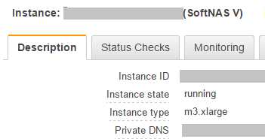

19. Note the **Public DNS** or **Public IP** for the selected instance.

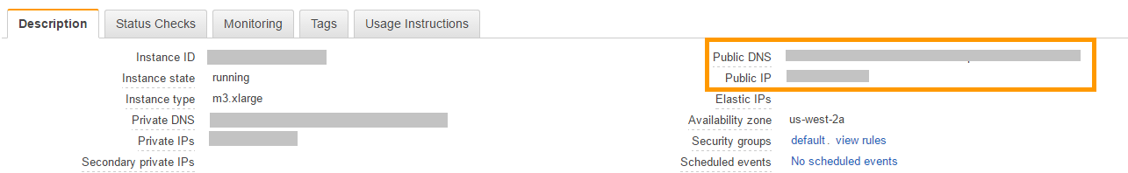

20. Replace token **<Public\_IP\_or\_Public\_DNS>** in URL **https://<Public\_IP\_or\_Public\_DNS>** with a Public DNS or a Public IP and go to that URL in a browser.

Generally, a privacy error warning due to a self-signed SSH certificate will pop up. Ignore this for now and continue browsing.

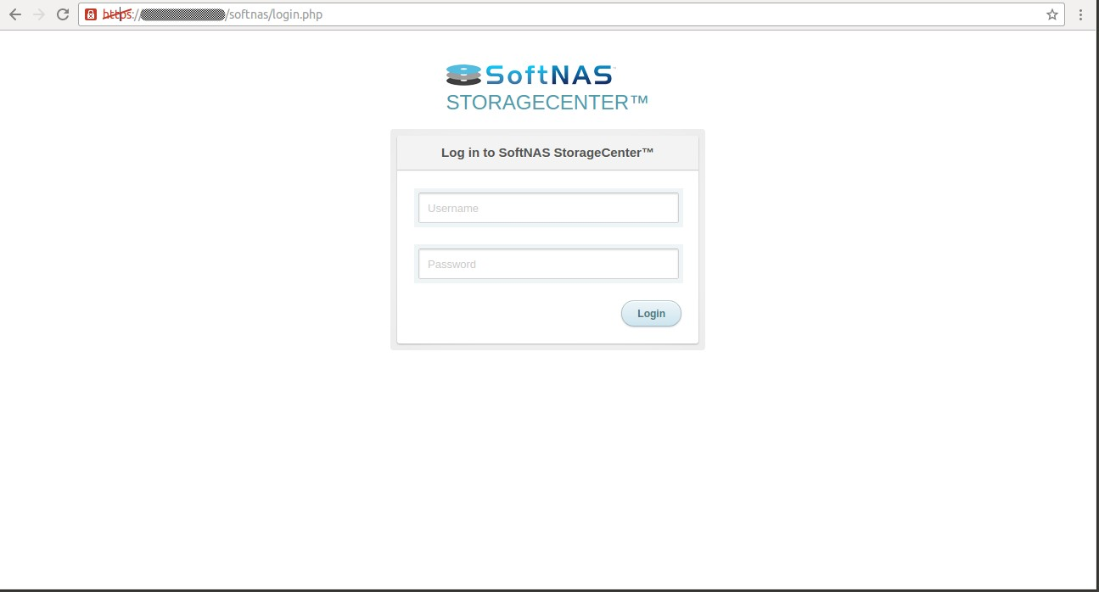

21. Log in to SoftNAS using the following credentials.

* Username: softnas
* Password: Instance ID of EC2 instance.

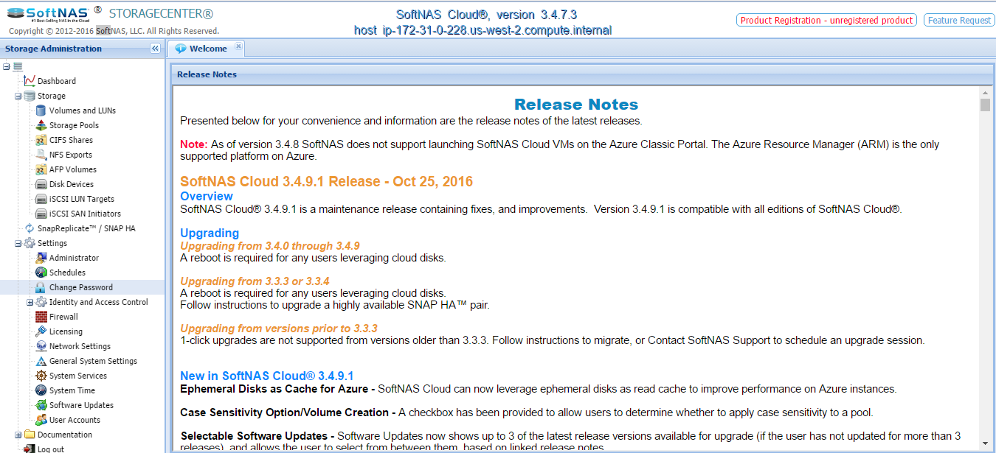

22. Click on the **Disk Devices** menu listed under **Storage** group on the left navigation panel.

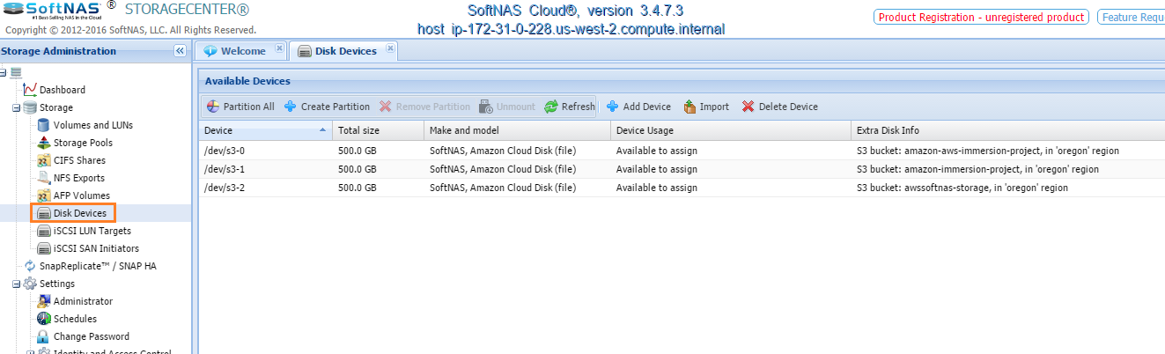

23. Click on the **Add Device** button.

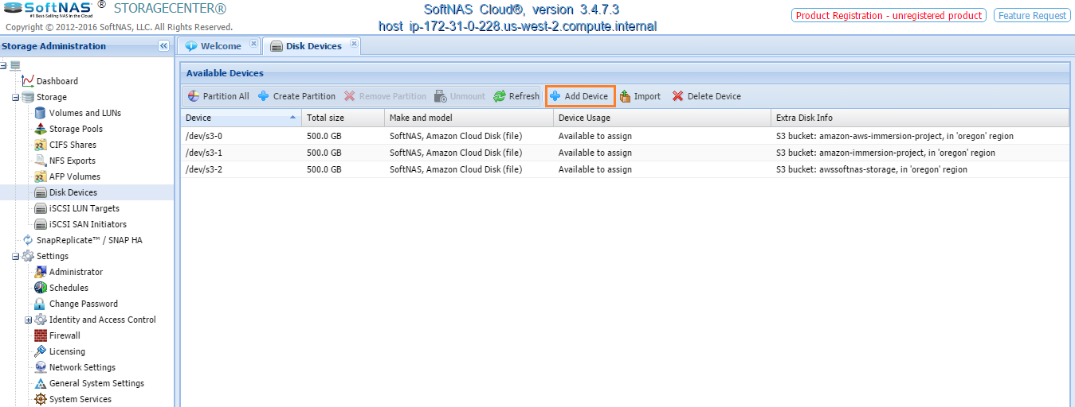

24. Select **Amazon Web Services S3** as **Cloud Disk Extender**.

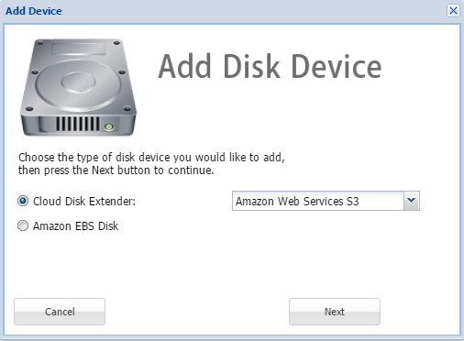

25. Click on **Next** and enter the following details:

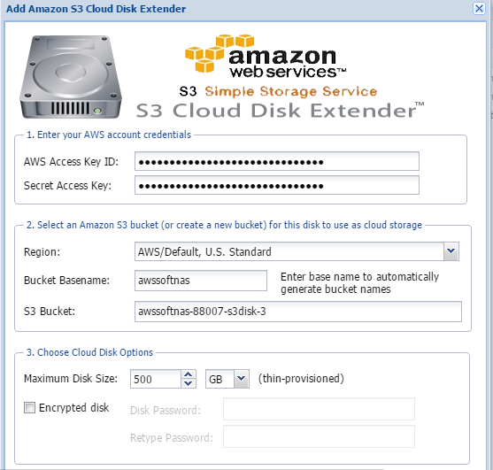

* **AWS Access Key ID:** Enter the Access Key that you got during the IAM User creation Step 1.2 from the Prerequisites document.
* **Secret Access Key:** Enter the Secret Access Key that you got during the IAM User creation Step 1.2 from the Prerequisites document.
* **Region:** Select as AWS/Oregon.
* **Bucket Basename:** Type in your choice. (Should be all lowercase)
* **S3 Bucket:** This will be generated automatically based on the previous input.
* **Maximum Disk Size:** Select as per your need.
* **Encrypted Disk:** Check this option if you want to encrypt the disk and enter a password.

26. Click on the **Create S3 Cloud Disk** button to create a new Amazon S3 bucket.

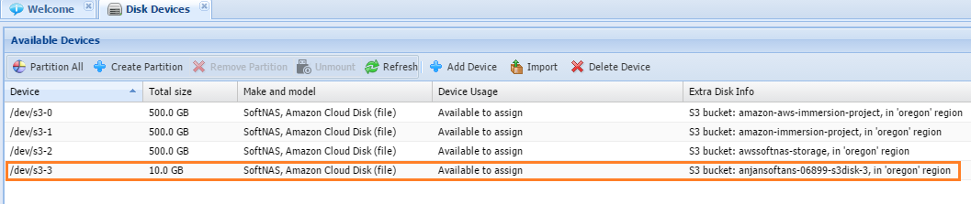

27. Go to the AWS Services page and click on **S3** which is listed under Storage and Content Delivery.

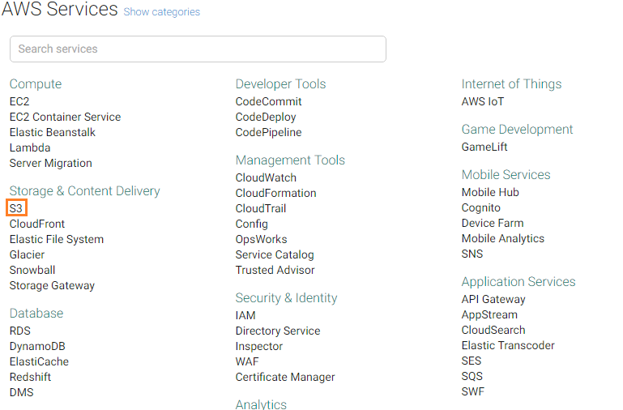

28. You will get a list of Amazon S3 buckets that were created under the account. Click on the Amazon S3 bucket listed under the left navigation panel.

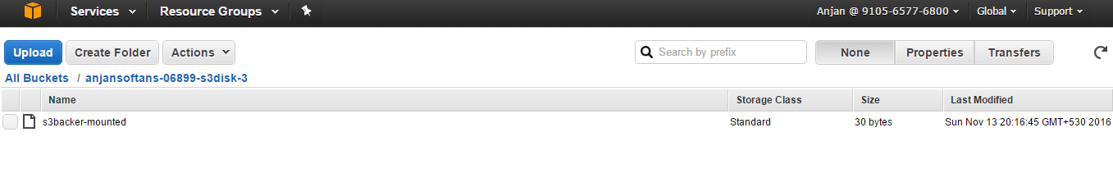

29. Now you can use this S3 bucket and upload files as needed.

**Benefits:**

SoftNAS maintains storage space automatically. The size of an AWS bucket grows as it is used. But, there must be some constraint, such as limiting the space usage. You can create an S3 bucket and limit the size, so usage does not cross that limit. Only this space will be usable for that bucket. Also, this bucket is managed by SoftNAS.

If you need to add more space, another disk, virtual space, or maintain all the space or disks, it can be done using SoftNAS.

**Alternatives:**

The Amazon Elastic File System (Amazon EFS) provides simple, scalable file storage for use with Amazon EC2 instances in the AWS Cloud.

4.3. Setup the Warehouse using Amazon Redshift Data Warehouse (E)

1. Log in to the Amazon Management Console.

2. Inside the **AWS Services** listing, locate the **Redshift** service listed under **Database** services.

3. Choose **Redshift**.

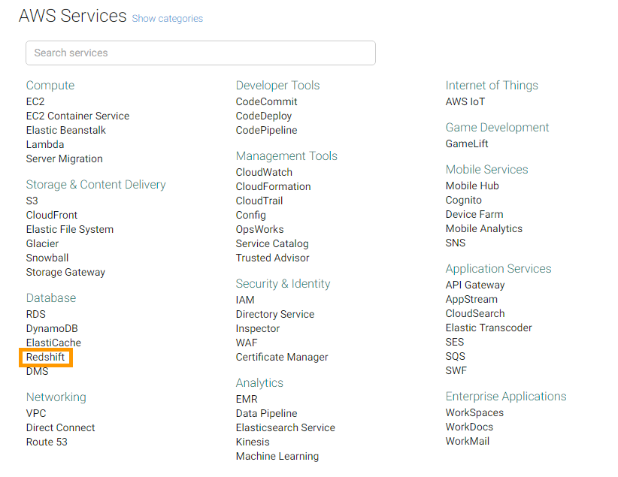

4. Click the **Launch Cluster** button in the Redshift Dashboard.

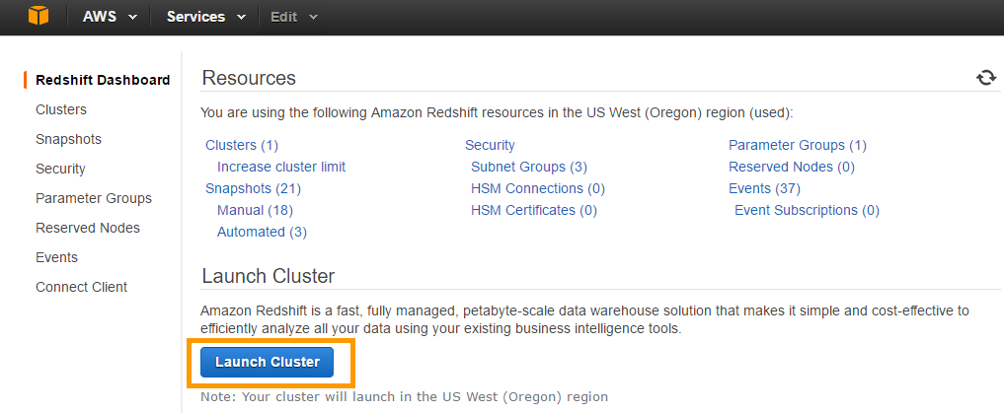

5. This step will open a page, containing three tabs to collect details for creating a cluster.

4.3.1. Cluster Details

6. Enter information in the **Cluster Details** tab as shown below:

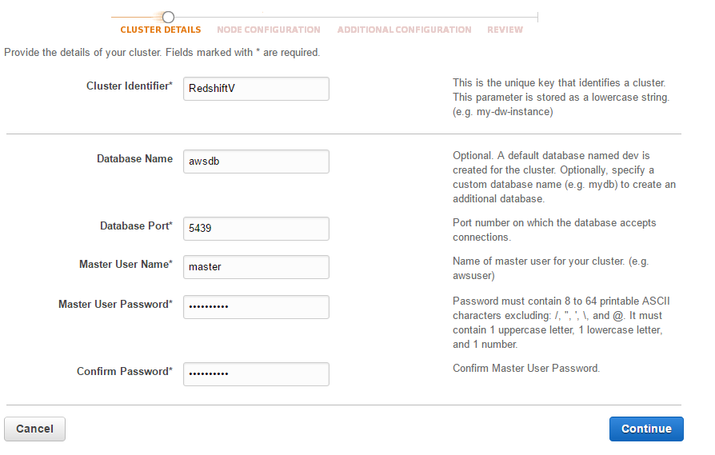

* **Cluster Identifier:** Give the cluster a name as per your wish.
* **Database Name:** This is the database identifier. Name it as per your choice.
* **Database Port:** Use port number **5439** for Redshift and add a firewall exception for this port in the client systems.
* **Master User Name:** This is the user name required to connect to the cluster when the cluster is available. Give a User Name as per your choice.
* **Master User Password:** Give a password as per your choice.
* **Confirm Password:** Enter the same password that you have entered above.

7. Make note of the **Database Name, Database Port, Master User Name** and **Master User Password.** These properties will be required in the creation of ATTUNITY Replicate Endpoint Connection.

After specifying all the details in the Cluster Details box, click on the **Continue** button. This will lead you to the next page.

4.3.2. Node Configuration

8. Enter the following details in the Node Configuration tab.

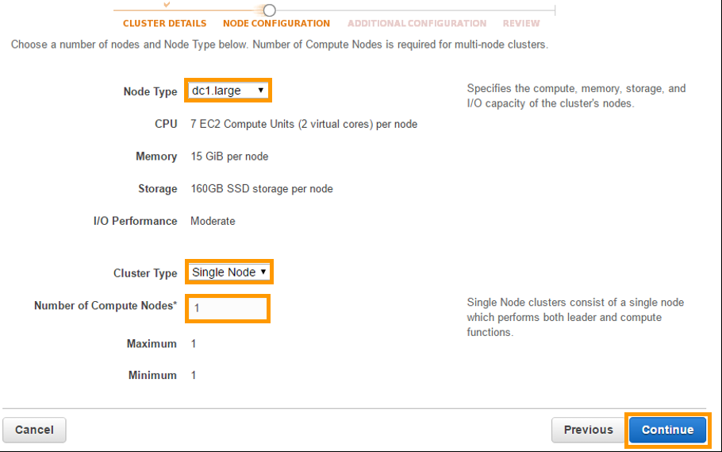

**Node Type:** Select **dc1.large.**

**Cluster Type:** Select **Single Node.**

**Number of Compute Nodes:** Set this to **1**.

1. After specifying all the details, press **Continue**. This will lead you to the Additional Configuration Tab.

4.3.3. Additional Configuration

1. Enter the details in the **Additional Configuration** tab as shown below.

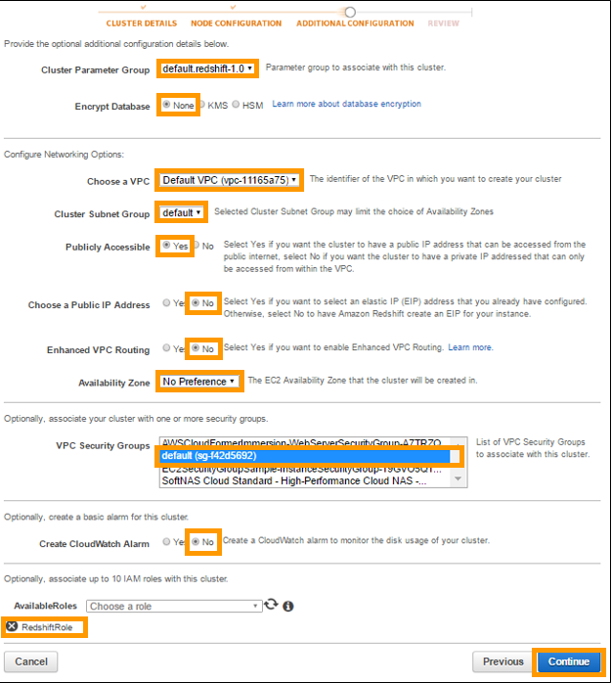

* **Cluster Parameter Group:** Cluster Parameter Group acts as a container for engine configuration values that are applied to a cluster. Select the **default** for the cluster parameter group.
* **Encrypt Database:** If this feature is enabled, then the database will be encrypted. Currently encryption is not required.
* **VPC:** Select the **Default VPC**.
* **Cluster Subnet Group:** Select the **default** Cluster Subnet Group.
* **Publicly Accessible:** Select “**Yes**”, because this cluster needs to be accessed from the public network.
* **Choose a Public IP Address:** Choose “**No**” to let Redshift provide an Elastic IP (EIP). If you select “**Yes**”, then make sure that you own a Public IP from a list of EIP that are already configured for your cluster’s VPC.
* **Availability Zone:** Select the default **No Preference**. This will decide the availability zone for the cluster. Let Amazon decide which zone is good for us by selecting **No Preference**.
* **VPC Security Group:** Select **default** VPC Security Group.
* **CloudWatch Alarm:** Select “**Yes**” if you want to monitor disk usage of the cluster; otherwise select “**No”**.
* **Available Roles:** Select **RedshiftRole** created for cluster.

11. Press the **Continue** button at the bottom of tab.

4.3.4. Review

This tab will display a summary of all the properties set in all the previous tabs, and the pricing information for this cluster.

12. If all the properties are correctly set, click on the **Launch Cluster** button at the bottom of the page to finalize the cluster creation.

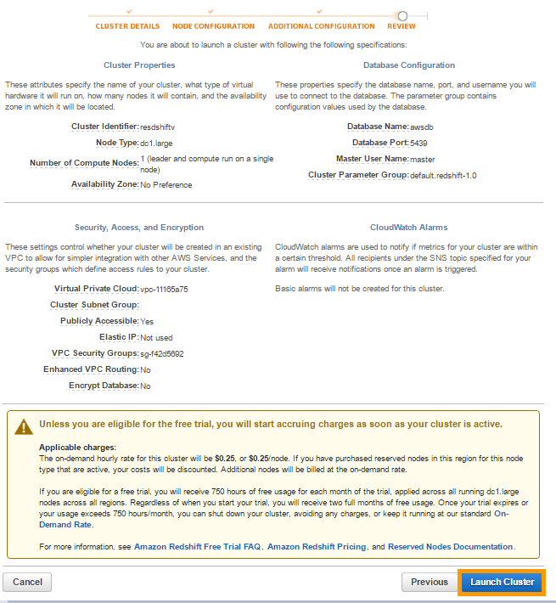

A page similar to the one shown below signifies the successful initiation for the cluster creation.

Wait for a few minutes for your cluster to be created.

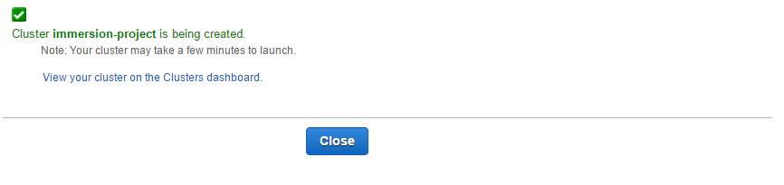

13. Click on the link **View your cluster on the Clusters dashboard** to see cluster status, health, etc., like the example below:

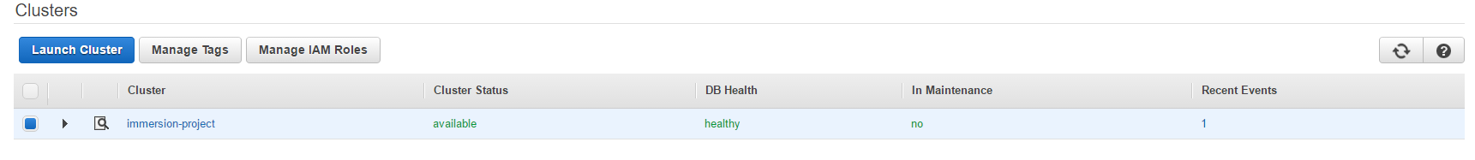

14. Click the link attached to the name of the cluster to open the cluster details page.

15. From the **Configuration** tab of the cluster details page, copy **Endpoint of cluster**.

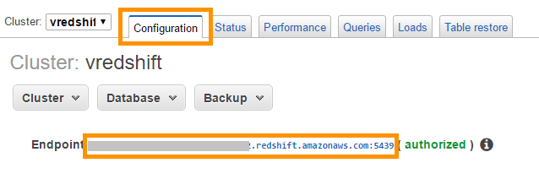

Endpoint of cluster will be required in the creation of ATTUNITY Replicate Endpoint Connection.

**Benefits:**

Amazon Redshift is a fully managed, petabyte-scale data warehouse service located in the cloud. You can start with just a few hundred gigabytes of data and scale to a petabyte or more. This enables you to use your data to acquire new insights for your business and customers.

**Alternatives:**

Currently we have not found another service with the similar performance of Redshift.

4.4. Setup the ETL Tool using ATTUNITY CloudBeam ETL (C)

4.4.1. Launch ATTUNITY CloudBeam Instance

1. Log in to the **AWS Management Console**.
2. In the right side of the navigation panel, click on the link **“Find and buy software”** to open AWS Marketplace.



1. Type **ATTUNITY** in the search box of AWS Marketplace and press the **Go** button.

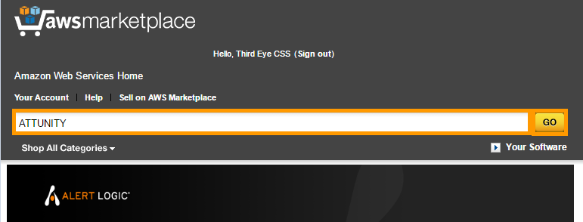

1. Search for “**ATTUNITY CloudBeam for Amazon Redshift (Express) – Hourly”** in the result list. Click on it to open the product details page.

Note: If the Account already contains **ATTUNITY CloudBeam for Amazon Redshift (Express) – Hourly** instance then use **ATTUNITY CloudBeam for Amazon Redshift (Premium) – Hourly** for your next instances. Steps for installation of **ATTUNITY CloudBeam for Amazon Redshift (Premium) – Hourly** will be same.

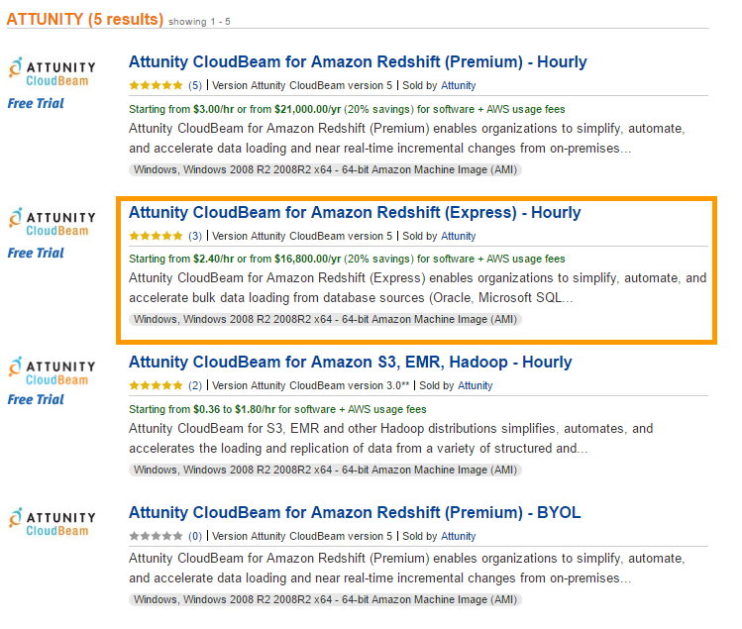

1. Click on the **Continue** button on the product description page.

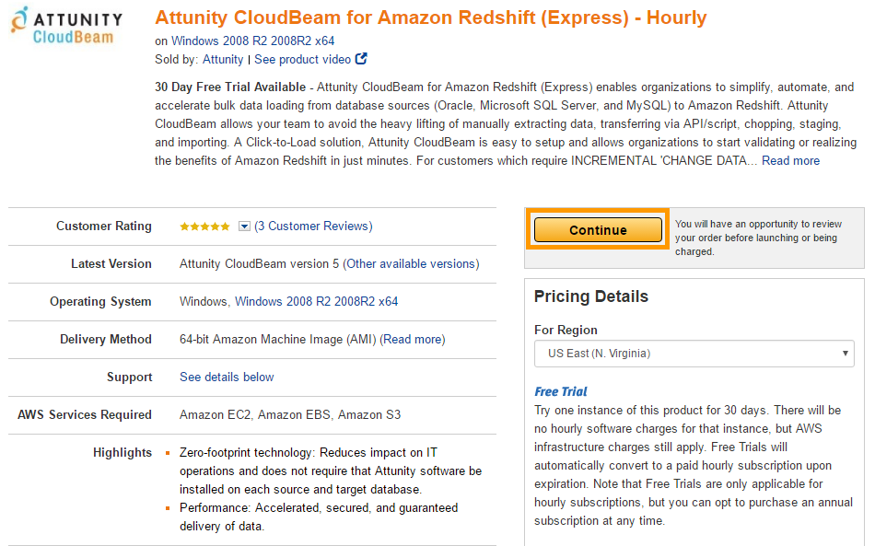

1. On the **Launch on EC2** page, make sure the **1-Click Launch** tab is selected.

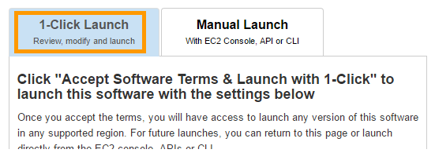

1. Set **Subscription Term** to **Hourly** in the Software Pricing section.

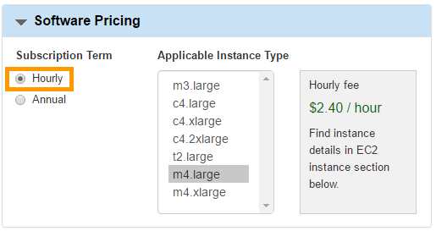

1. Select **latest version** of ATTUNITY CloudBeam.

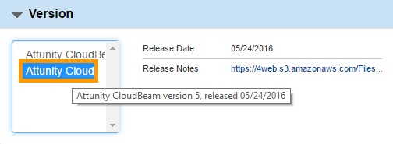

1. Select **US West (Oregon)** option for **Region** property.

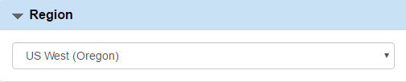

1. Choose **m4.large** EC2 Instance type.

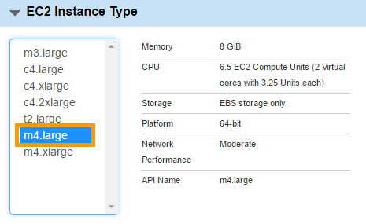

1. Select default **VPC** and default **Subnet**. Default VPC and Subnet are marked by **asterisk** **“\*”** sign**.**

**Note:** VPC and Subnet should be the same as those used while creating a Redshift cluster.

1. Select **default** for the Security Group.

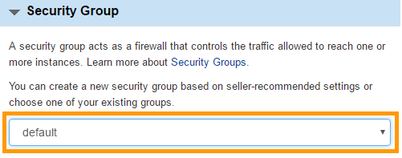

1. For property **Key Pair**, choose the key pair you created while following the steps in **Section 1.4, “Generate Your Private Keys,”** in the **Prerequisites** document.
2. Now scroll up and click on the **Launch with 1-click** buttonto launch the instance.

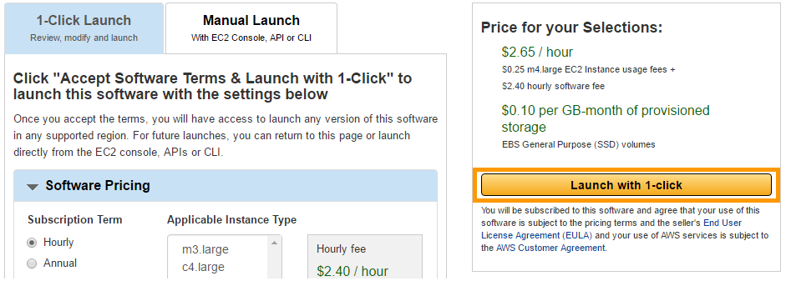

1. After few minutes, go to the **Amazon EC2 dashboard** to check the status of the newly created instance.

4.4.2. Connect to ATTUNITY CloudBeam instance remotely

1. To configure ATTUNITY CloudBeam instance, first make sure it is running.
2. Select the **ATTUNITY CloudBeam** **EC2** instance and right click on it.
3. Then click **Connect** (listed on the menu).
4. Click on **Download Remote Desktop File** on the **Connect To Your Instance** popup window.
5. After downloading the file with an “RDP” extension, click on the **Get Password** button in the **Connect To Your Instance** popup window.

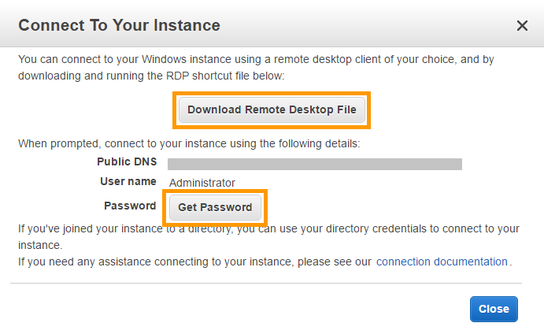

1. In the **Connect To Your Instance** > **Get Password** window, click on the **Choose File** button and browse for the file that has a **“.PEM”** extension. This file contains the Private key that you generated in **Section 1.4: Generate Your Private Keys** and assigned to the ATTUNITY CloudBeam instance in **Step 13 of Section 4.4.1**.

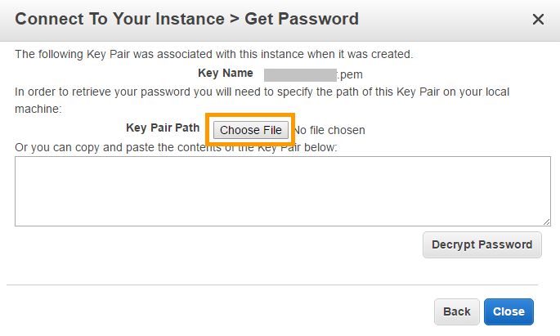

1. After you see the content of Private Key file, click on the **Decrypt Password** button.

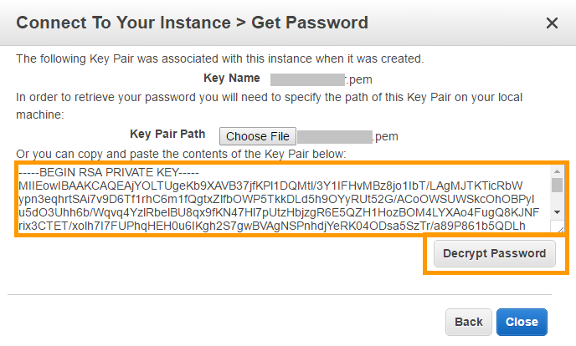

1. Make note of the Username and Password generated in the **Connect To Your Instance** popup window.

This password will be used while making remote connections to this instance.

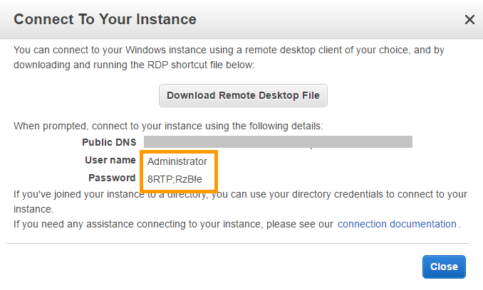

1. Now open the file with **“RDP”** extension downloaded in **Step 4** of this section and make a secure connection using the credentials obtained in **Step 8** of this section.

**Note:** In Linux, generally there is no RDP client pre-installed on your system. Although you can install Remmina Remote Desktop Client. Provide the Public DNS for the instance at the location where Computer name is required. And then provide the User name as Administrator and the Password that you just generated. Then log in remotely. If a screenshot appears showing that the Security Certificate is out of date or expired or not recognized, don't worry, just accept the condition and proceed.

10. After a successful remote desktop connection to ATTUNITY Cloudbeam instance, you will see a window as shown in the image below:

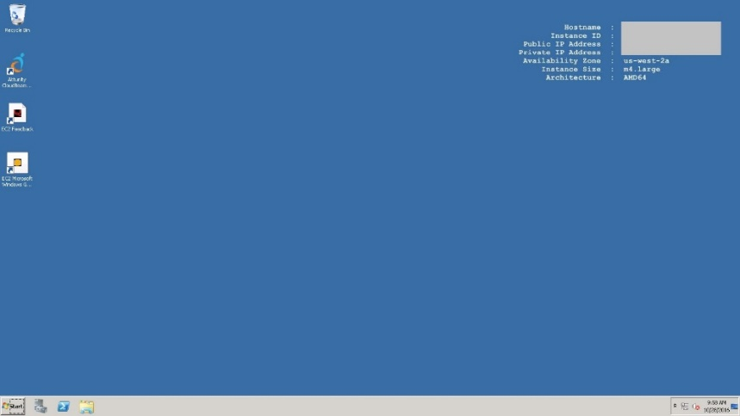

4.4.3. Set ATTUNITY CloudBeam Password

1. Use the remote desktop connection to ATTUNITY CloudBeam instance that you created in **Section 4.4.1.**
2. Double-click on **ATTUNITY CloudBeam Configuration icon** to start the configuration wizard.

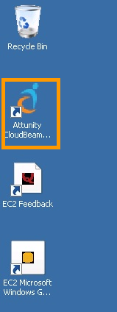

1. Follow the steps mentioned in the configuration window to set the password. Make a note of this password.

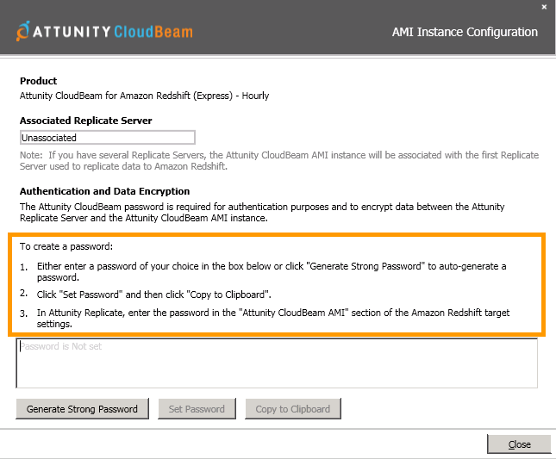

1. Close the configuration window.

4.4.4. Install ATTUNITY Replicate software

Once ATTUNITY CloudBeam for Redshift EC2 instance is launched for the first time, you will get an e-mail from the ATTUNITY CloudBeam-AWS Marketplace.

Mail will be sent to the e-mail ID used for the registration of the AWS Account (Root Account).

If you are working with an individual account with limited privileges, don't assume that the email will arrive in your mailbox.

1. After receiving the e-mail, check the content for the link to download the ATTUNITY Replicate software.

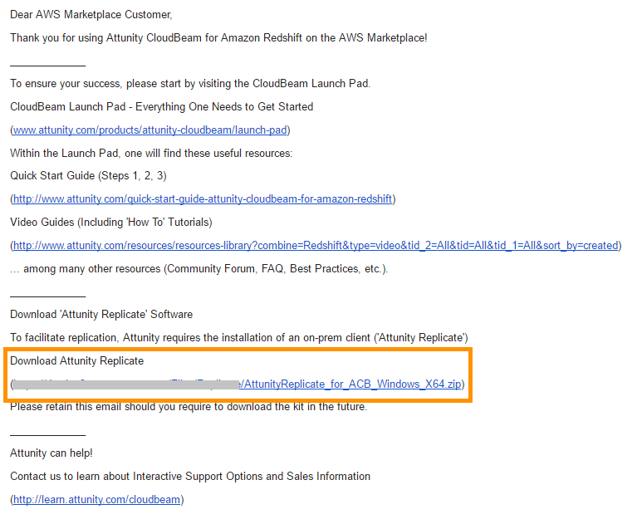

1. Click on the link in the browser of ATTUNITY CloudBeam instance created in **Section 4.4.1.** It will download the software in a zip file.
2. After downloading the software, extract the archive in a separate folder and install the ATTUNITY Replicate software by double clicking on the **.exe** file.
3. While installing the ATTUNITY Replicate software, for the Replication Server Location, choose **Install a local Replicate Server** option.

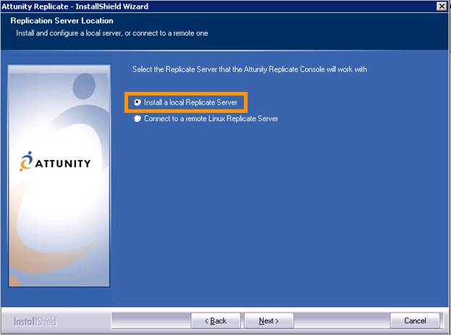

4.4.5. Install MySql 5.5

1. Download and install the **Microsoft Web Platform Installer** in the ATTUNITY CloudBeam instance created in **Section 4.4.1**. (To get the installation file, open the URL <https://www.microsoft.com/web/downloads/platform.aspx> in your browser)
2. Open the **Microsoft Web Platform** and select the **Products tab.**

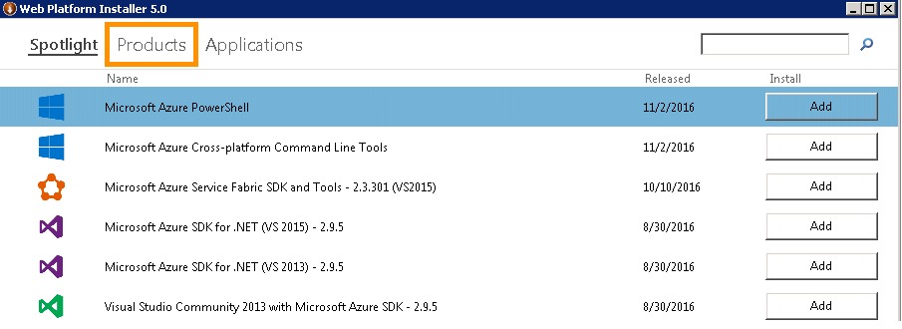

1. Enter the word **mysql** in the search box and press the **Enter** button on your keyboard.

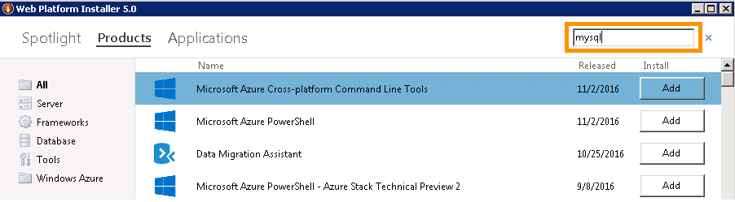

1. Select **MySQL Windows 5.5** from the search results and click on the **Add** button to add it in installation list.

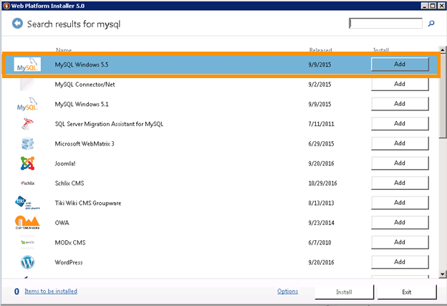

1. Click on the **Install** button to start the installation of MySQL 5.5.

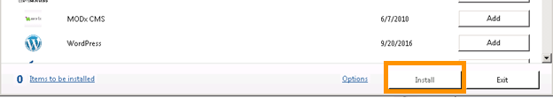

1. Enter the **Password** on the Prerequisites tab and click on the **Continue** button.

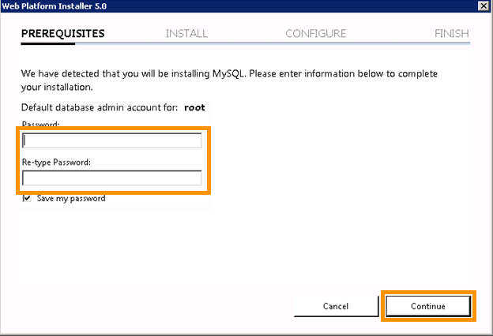

1. Make note of this MySQL password for future use.
2. After completion of the installation, click on the **Finish** button to close the window.

**Benefits:**

This MySQL Server is required because ATTUNITY CloudBeam can only fetch data from MySQL, Microsoft SQL Server, or Oracle. MySQL is open source. MySQL is a standard RDBMS solution.

**Alternatives:**

1. MySQL RDS.

2. Microsoft SQL Server RDS.

3. Oracle RDS.

4. Microsoft SQL Server (on-prem).

5. Oracle (on-prem).

4.4.6. Install MySQL Connector/ODBC driver

1. Go to the URL <https://dev.mysql.com/downloads/connector/odbc/> in the browser of ATTUNITY CloudBeam instance created in **Section 4.4.1**.
2. Go to the **Generally Available (GA) Releases** section of the page.
3. Select **Microsoft Windows** option from the Select Platform drop down list and click on **Looking for Previous GA versions?**

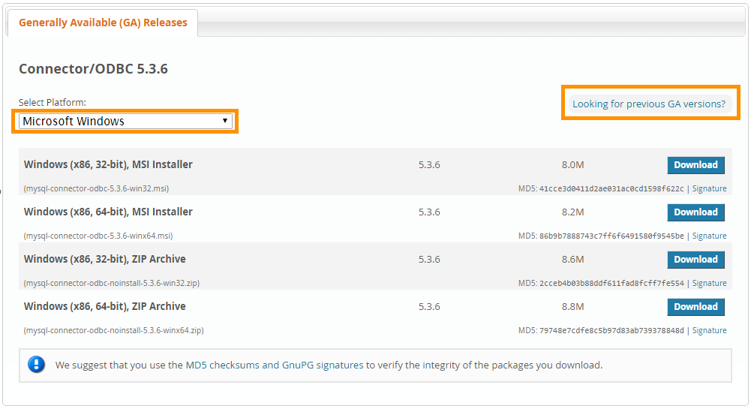

1. Select **version 5.2.7** and click on the **Download** button next to **Windows (x86, 64-bit), MSI Installer**.

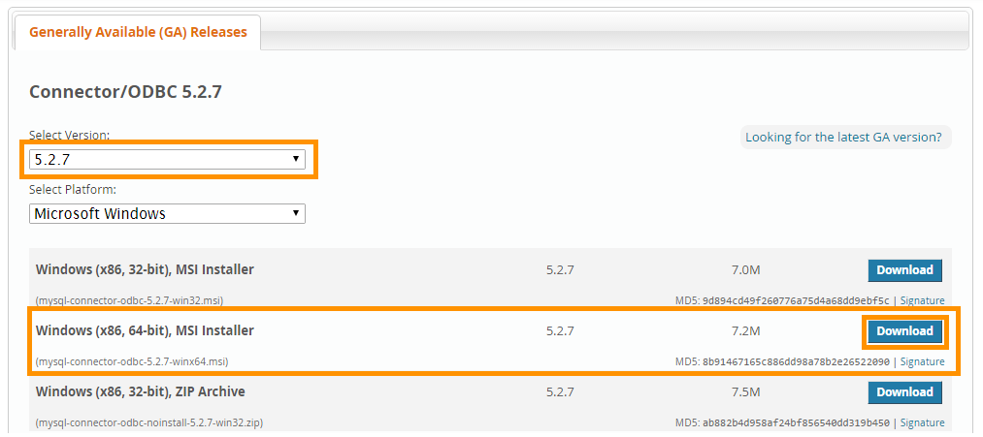

1. On the **Begin Your Download** page, click on the link **No thanks, just start my download** to download the installation file without having to register.

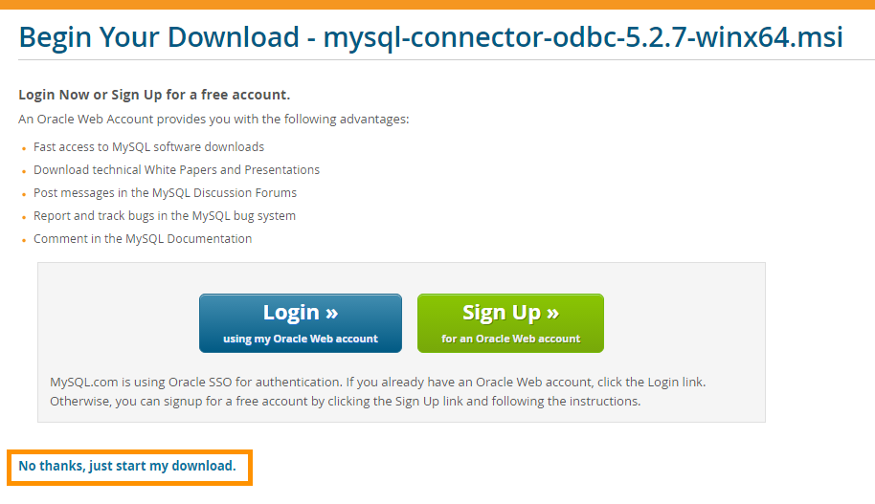

1. Install the downloaded installation file.
2. **Reboot** the ATTUNITY CloudBeam instance created in **Section 4.4.1.**
3. Make a remote connection to the same instance.
4. **Restart** the ATTUNITY Replicate server.

* Go to **Start -> All Programs -> ATTUNITY Replicate -> Utilities** and click on **Stop Replicate Server**.
* Then again start it from **Start -> All Programs -> ATTUNITY Replicate -> Utilities** and click **Start Replicate Server**.

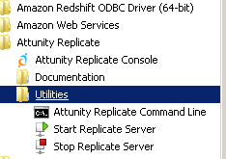

4.4.7. Create MySQL Database

1. Click the **Start** button on your taskbar and select **MySQL 5.5 Command Line Client**.

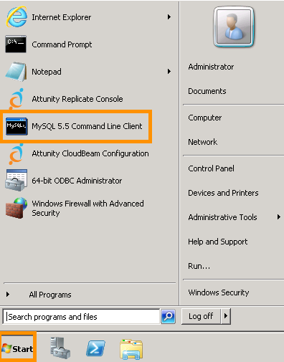

1. You will be asked to provide the MySQL password on CLI. Enter the password you provided in **Step 6 of Section 4.4.5: Install MySql 5.5** and press Enter to start the MySQL shell.

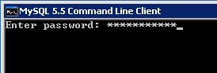

1. Execute this command in MySQL shell to create a new database in MySQL.

Replace token **<DataBase\_Name>** with a suitable name for a database before executing the command.

**Note**: Semicolon (**‘;**’) is a must at the end of each MySQL command; it signifies the end of a statement.

|  |
| --- |
| create database **<Database\_Name>;** |



1. Make a note of this database name for future steps.
2. Execute the statement below to set a newly-created database as the current database.

Before executing this command, replace the token **<Database\_Name>** with the name of database created in Step 3.

|  |
| --- |
| use <Database\_Name>; |



1. Execute the following statement to create a **company\_master** table in the new database.

|  |
| --- |
| create table if not EXISTS company\_master  (company\_id int PRIMARY KEY,  company\_name varchar(255),  company\_symbol varchar(255),  company\_address text,  company\_foundedon date,  company\_ceo varchar(255),  comapny\_assets double,  company\_revenue double); |

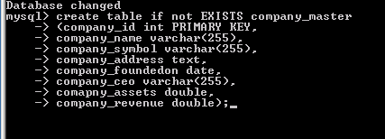

1. Execute the following statement to create a **company\_product** table in a new database.

|  |
| --- |
| CREATE TABLE IF NOT EXISTS company\_product  (product\_id int PRIMARY KEY,  company\_id int,  product\_name varchar( 255 ),  product\_description text,  product\_type varchar( 255 ),  product\_initialrelease date,  product\_marketvol double,  product\_manufacture\_lat float,  product\_manufacture\_long float,  product\_manufacture\_loc varchar( 255 )); |

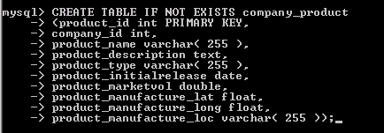

1. Execute the following statement to create a **company\_announcement** table in a new database.

|  |
| --- |
| CREATE TABLE IF NOT EXISTS company\_announcement  (announcemnt\_id int PRIMARY KEY,  company\_id int,  announcemnt\_date date,  announcemnt\_title varchar( 255 ) ,  announcemnt\_by varchar( 255 ) ,  announcemnt\_from varchar( 255 ) ,  announcemnt\_path text); |

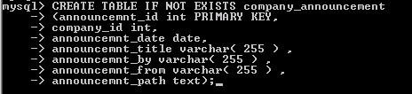

4.4.8. Create Bucket

1. Log in to [*https://console.aws.amazon.com/console*](https://console.aws.amazon.com/console)
2. Click on **S3** under **Storage and Content Delivery** in the AWS Services box.

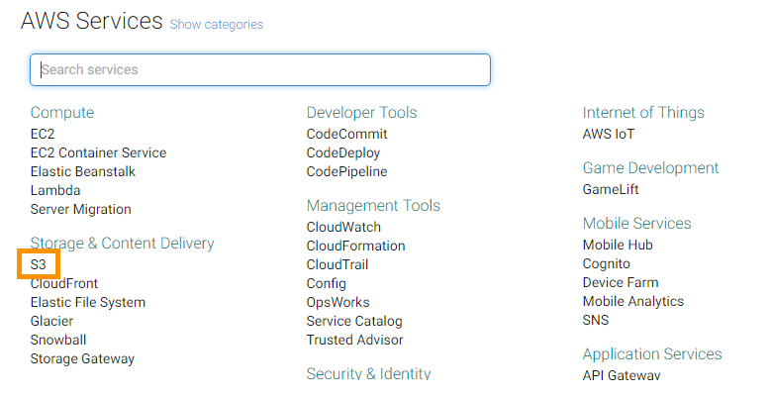

1. Click on the **Create Bucket** button in the upper left corner of the S3 console.

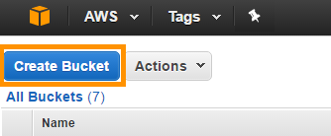

1. In the **Create a Bucket** popup window, enter an appropriate **name for bucket**, select **Region** and click on the **Create** button.

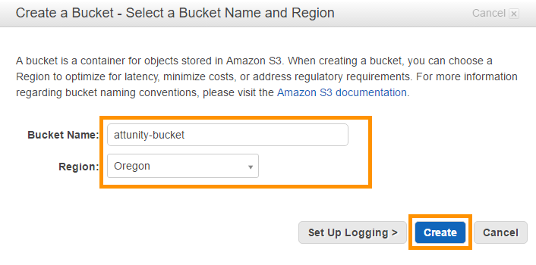

1. Make a note of the **Bucket Name** for future use.

4.4.9. Create ATTUNITY Replicate Endpoint Connections

1. Open the **ATTUNITY Replicate Web Console** (Start->All Programs->ATTUNITY Replicate->ATTUNITY Replicate Console)
2. ATTUNITY Replicate Web Console is a web application. While opening, if it gives a Certificate error like below, just ignore it and continue browsing.

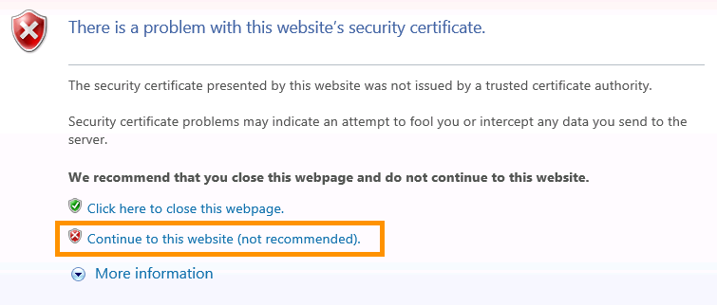

1. Click on the Manage Endpoint Connections menu.

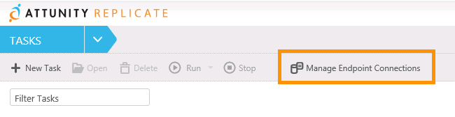

1. Click on the **+ New Endpoint Connection** menu in the Manage Endpoint Connections popup window.

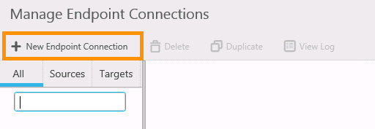

1. In the content section of the popup window, set the following properties for a new endpoint connection:

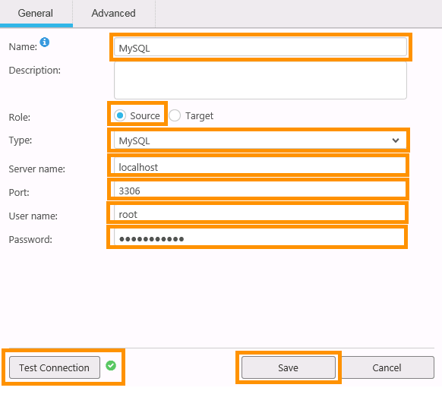

* Name: MySQL
* Role: Source
* Type: MySQL
* Server Name: localhost
* Port: 3306
* User name: root
* Password: Enter the MySQL password that was set in **Step 6** of **Section 4.4.5 Install MySql 5.5**

1. Click on the **Test Connection** button located at the bottom of the window to confirm the connection properties. A green **OK** sign will appear if all properties are correct.
2. Click on the **Save** button to finalize all the properties for this connection.
3. Click on the **+ New Endpoint Connection** menu again to set properties for a new connection.
4. In the content section of the popup window, set the following properties for a new endpoint connection:

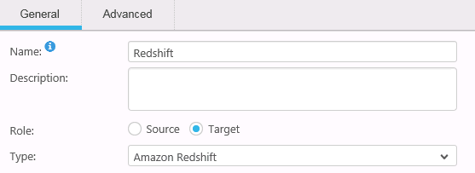

* Name: Redshift
* Role: Target
* Type: Amazon Redshift

Expand the Amazon Redshift target section and set the properties of the Amazon Redshift cluster created in **Section 4.2: Setup the Warehouse using Amazon Redshift Data Warehouse (E)**

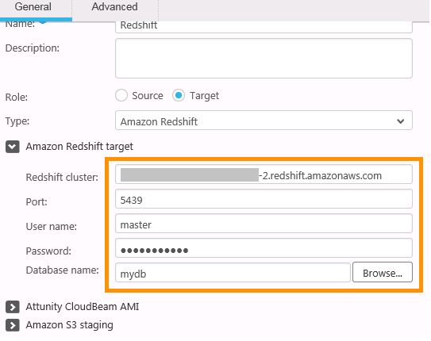

* **Redshift cluster**: Type in the Redshift cluster endpoint obtained in **Step 15 of Section 4.3: Setup the Warehouse using Amazon Redshift Data Warehouse (E),** but remove the colon and port number at the end of the string.

Enter the following details of the Redshift cluster copied in **Step 8 of Section 4.3.1: Cluster Details**

* Port = Database Port
* User name = Master User Name
* Password = Master User Password
* Database name = Database name

Expand the ATTUNITY CloudBeam AMI section and set the properties of ATTUNITY CloudBeam instance.

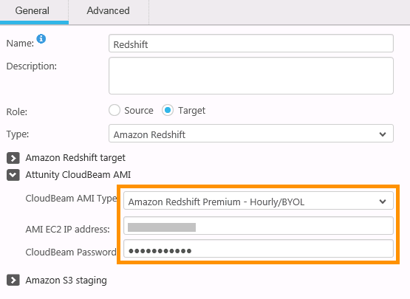

* CloudBeam AMI Type: Select the CloudBeam AMI Type used for creating the instance in **Step 4** **of Section 4.4.1: Launch ATTUNITY CloudBeam Instance**
* AMI EC2 IP address: Enter the Public IP of ATTUNITY CloudBeam instance created in **section 4.4.1: Launch ATTUNITY CloudBeam Instance**
* CloudBeam Password: Enter the password set in **Step 3** **of** **Section 4.4.3: Set ATTUNITY CloudBeam Password**

Expand the Amazon S3 staging section and set the following properties:

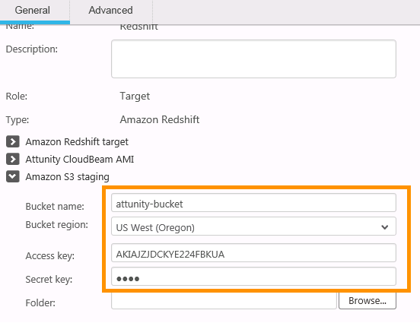

* Bucket Name: Type the name of the S3 bucket created in **Section 4.4.8: Create Bucket**
* Bucket Region: Set the same region used while creating the above bucket.
* Set **Access Key** and **Secret Key** to the *Access Key ID* and *Secret Access Key* respectively present in the file downloaded in **Step 12 of Section “Create IAM Users”** in the **Prerequisite** document.

10. Click on the **Test Connection** button at the bottom of the window to confirm the connection properties. A green **OK** sign will appear if all properties are correct.

11. Click on the **Save** button to finalize all the properties for this connection.

4.4.10. Create ATTUNITY Replicate Task

1. Open the home page of ATTUNITY Replicate Web Console.
2. Click on the **+ New** Task button on menu bar.

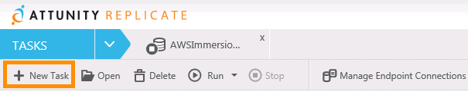

1. In the **New Task** window, set the following properties and click on the **OK** button at the bottom to create a new task.

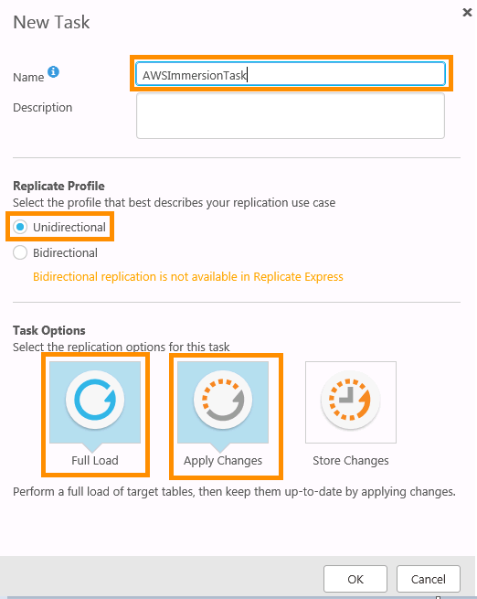

* Name: Type in a suitable name for the task.
* Replicate Profile: **Unidirectional**
* Task Options: Select **Full Load** and **Apply Changes** options as shown in the above image. Selected options become light blue.

1. In the **Task Editor,** you will be asked to provide **Source** and **Target** endpoints.

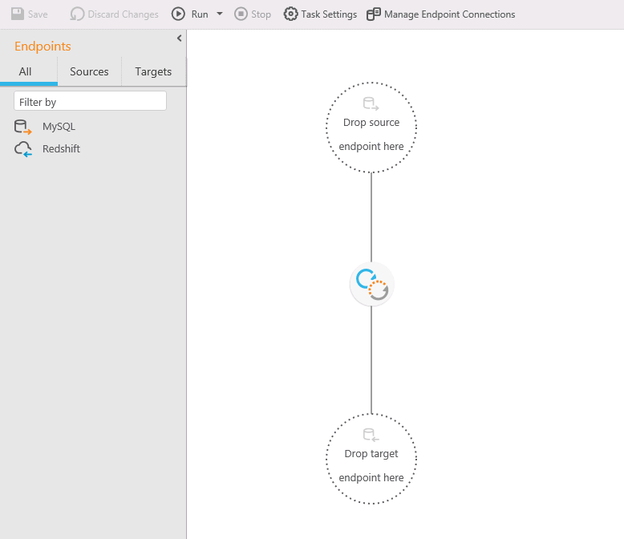

1. Drag and drop the respective endpoints (created in Step 4.4.7.) present in the Endpoints pane to their proper locations.
2. Click on the **Table Selection** tab present in right pane of the window.

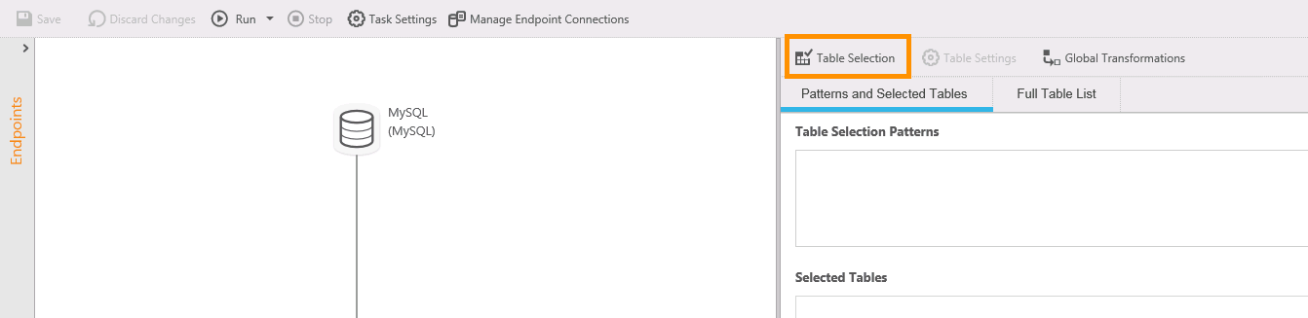

1. In the Select Tables popup window, expand the **Schema** dropdown list and select the MySQL database created in **Section 4.4.7: Create MySQL Database.**
2. Click on the **Search** button to search all tables present in the selected database. After this step, the Table List will get populated with names of tables present in the database.

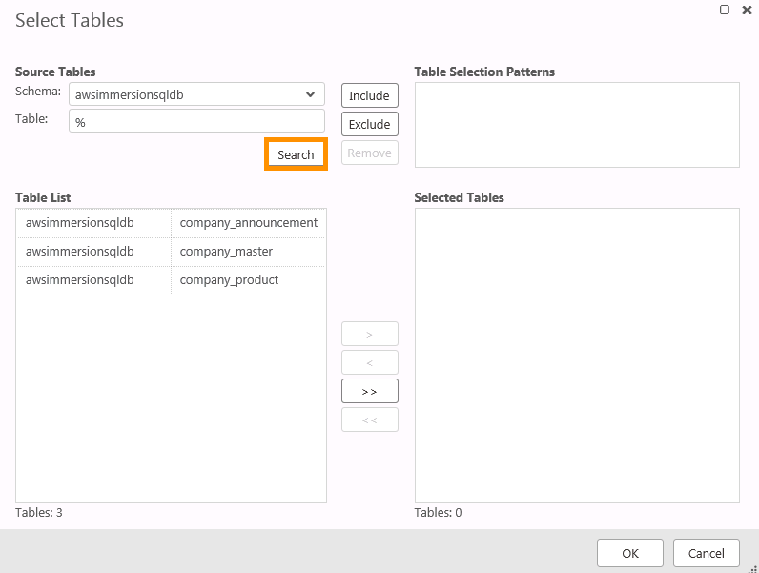

1. Click on the **Add All** button to select all the tables for the data transfer.

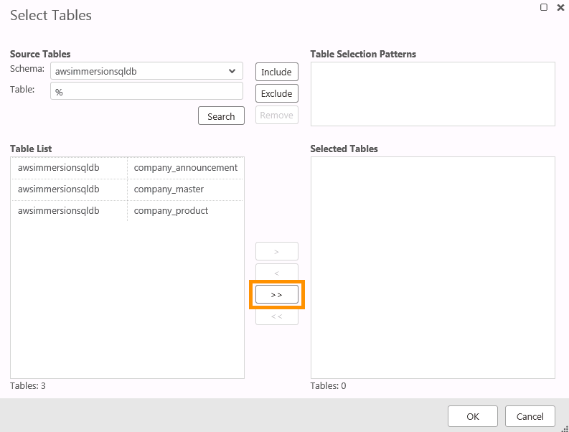

10. Click on the **OK** button present at the bottom of the Select Tables popup window.

11. Click on the **Save** button on the menu bar to finalize the endpoints for task.

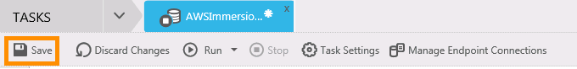

12. A newly-created task will appear on **ATTUNITY Replicate Web Console.**

**Benefits:**

ATTUNITY CloudBeam for Amazon Redshift (Express) enables organizations to simplify, automate, and accelerate bulk data loading from database sources (Oracle, Microsoft SQL Server, and MySQL) to Amazon Redshift.

**Alternatives:**

1. Informatica Cloud for Amazon Redshift (Screenshots)

2. Matillion ETL for Redshift

4.5. Visualization setup using TIBCO Spotfire Analytics platform (G)

4.5.1. Launch TIBCO Spotfire instance

1. Log in to [*https://console.aws.amazon.com/console*](https://console.aws.amazon.com/console).
2. In the right navigation panel, click on the link **Find and buy software** to open AWS Marketplace.



1. Type **TIBCO Spotfire** in the search box of AWS Marketplace and click on the **Go** button.

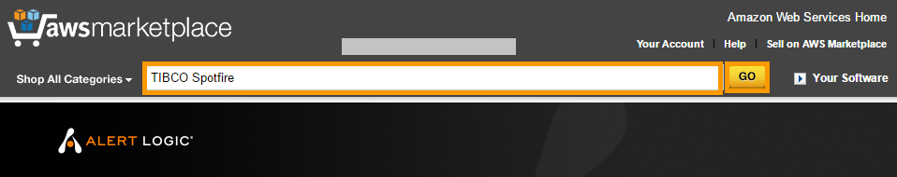

1. Click on **TIBCO Spotfire Analytics Platform (Hourly)** from the search results.

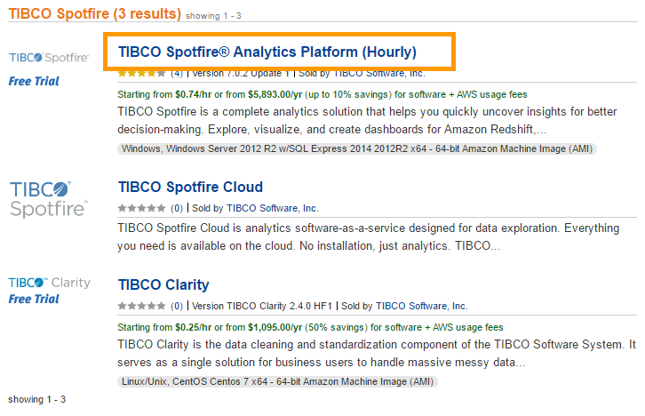

1. Click on the **Continue** button on the product description page of TIBCO Spotfire.

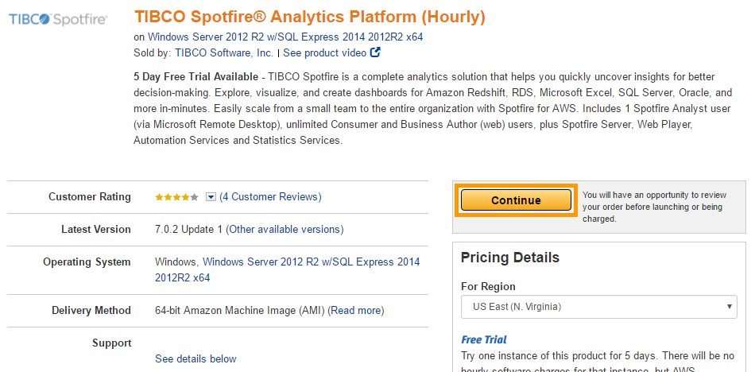

1. On the **Launch on EC2** page, make sure the **1-Click Launch** tab is selected.

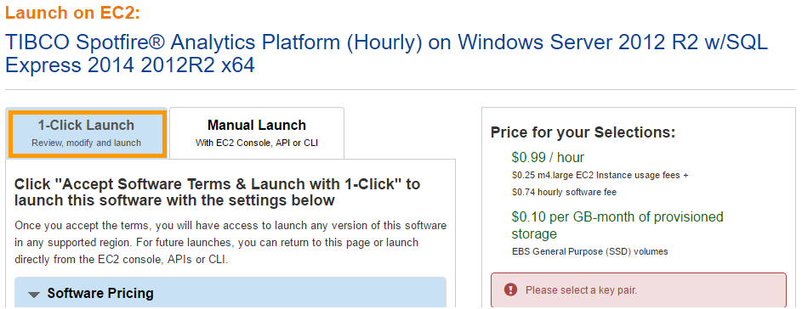

1. Set Subscription Term to **Hourly**.

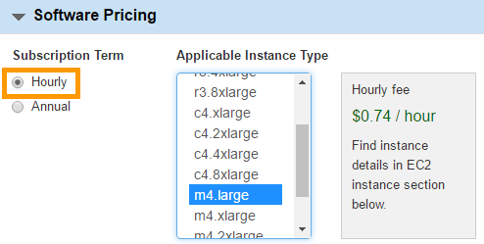

1. In the **Version** section, choose the latest version.
2. Select **US-West (Oregon)** as the default region for this project.



1. Select **m4.large** EC2 Instance type.

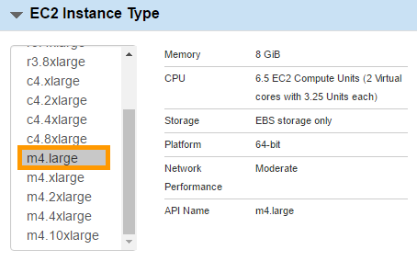

1. Select default **VPC** and default **Subnet**. Default VPC and Subnet are marked with an **asterisk** **“\*”.**



1. Select **default** Security Group.



1. If you have not done so already, follow the steps in **Section 1.4 “Generate Your Private Keys”** in the **Prerequisites** document to generate your key pair.
2. Select the generated key pair for the **Key Pair** selection box.



1. Scroll up and click on the button **Launch with 1-click** to start the TIBCO Spotfire installation process.

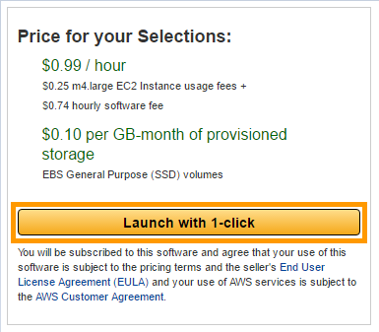

Wait for few minutes until the installation is completed.

16. **Go to the EC2 dashboard** to get a newly-created TIBCO Spotfire instance and provide a suitable name.

17. Make a remote connection to the newly-created TIBCO SpotFire instance by following the same steps mentioned in **Section 4.4.2: Connect to ATTUNITY CloudBeam Instance Remotely**.

18. After establishing a successful remote connection to the EC2 instance, a web form will open to collect details for the product registration.

19. Fill in the details and register the product or click the **No Thanks** link at the bottom of the form to skip registration.

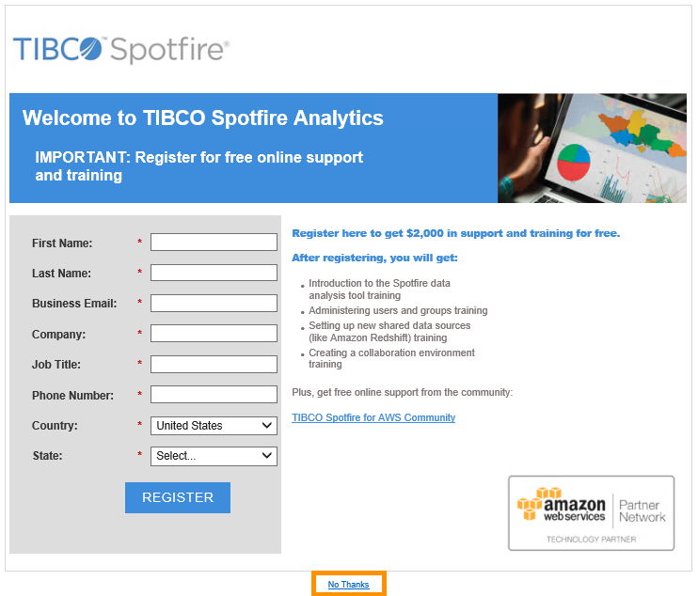

20. Now you will be redirected to the login page of TIBCO Spotfire Web Player.

Use the following credentials to log in to the TIBCO Spotfire Web Player.

**Username**: spotfireadmin

**Password**: instance ID of TIBCO Spotfire EC2 instance.

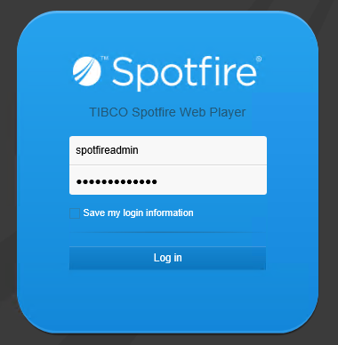

**Benefits:**

TIBCO Spotfire® Analytics Platform (Hourly) - TIBCO Spotfire is a complete analytics solution that helps you quickly uncover insights for better decision-making. Within minutes, you can explore, visualize, and create dashboards for Amazon Redshift, RDS, Microsoft Excel, SQL Server, Oracle, and more. You can also easily scale from a small team to an entire organization with Spotfire for AWS.

**Alternatives:**

Tableau Server, and many more.

4.5.2. Install Python

1. Click on the URL [*https://www.python.org/downloads*/](https://www.python.org/downloads/) in the browser of the TIBCO SpotFire EC2 instance to download the latest version of Python for Windows.
2. Download and install **Python 2.7.12** on the TIBCO SpotFire EC2 instance.
3. Follow the steps below to set a Path environment variable for the Python installation:

* For **Windows Server 2012** follow the path below to open Advanced System Settings
  + **Select Start > Control Panel > System and Security > System > Advanced System Settings**
* In the System Properties dialog window, select the **Advanced** tab and click on the **Environment Variable** button.
* In the Environment Variables dialog window, click on the **New** button in the System Variables section to add a variable.
* In the New System Variable window, type **PY\_HOME** as a Variable name and enter a **path to the Python installation directory.** The default is C:\PythonXX (XX is the version number).

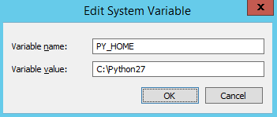

* Click on the **OK** button to save the variable.
* Select the **Path** System variable and click on the **Edit** button to modify it.
* Append the string **“;%PY\_HOME%;%PY\_HOME%\Scripts\”** at the end of the existing value of the Path variable. Semicolon “;” acts as a string separator.
* Click on the **OK** button to save the modification.
* Click on the **OK** button on the System Variable window.

1. Open the command prompt and execute a **python** command to check if Python is installed properly.

The following output below signifies a successful installation.

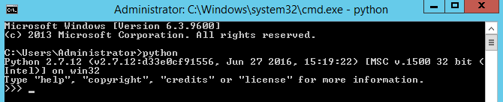

**Benefits:**

Python is a dynamic object-oriented programming language that can be compared with Java and Microsoft's .NET-based languages as a general-purpose substrate for many kinds of software development. It offers strong support for integrating with other technologies, higher programmer productivity throughout the development life cycle, and is particularly well suited for large or complex projects with changing requirements.

**Alternatives:**

Java, php, perl and many more.